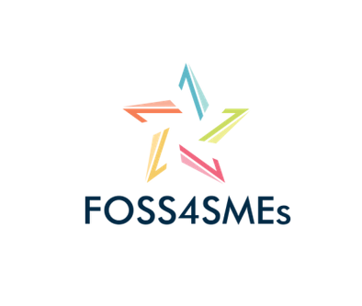





Minutes of FOSS4SMEs 2nd transnational Meeting, 3-4.05.18

**Mozilla premises - Schlesische Str. 27, 10997 Berlin, Germany**

**DAY 1,** **Thursday, 3 May 2018**

##### 1. Status of the project (slides 4-8)

• Project status overview

• Open issues

• Coming steps

##### 2. New team members introduced themselves

• OpenForum Europe (UK), Sivan Pätsch

• DUBLIN INSTITUTE OF TECHNOLOGY DIT (IR), Brian Gallispe

• Free Software Foundation Europe e.V. (DE), Max Mehl

##### 3. Organisational matters (slides 10-26)

1. **Time Sheets – Financial Information**

The team asked the coordinator to create a document with summarised information on the required documentation from each partner. Information on the deadlines is provided in the document.

Action taken after the meeting:

The document is called “FOSS4SMEs_Financial Information from partners v.1” and can be found now in Keybase under: K:\team\foss4smes\1. Management\Financial Information and Timesheets.

Questions of the team:

🡪 Concerning the short Output description that needs to be written in the timesheet ATL has proposed to use “O1/ A1 Desk and field research on existing training materials and curriculas relevant to the FOSS-Business User in Europe”. The team has asked if the description remains the same for the “manager” and the “technician”.

🡪 Concerning the hours filled in the xls sheets the team asked how to fill in the table if one person from the same organisation is being the manager, the researcher and the technician at the same time? Do we need different timesheets for the same person?

🡪 Concerning signing the timesheet: Sachiko asked if she can sign twice, once as a project member and once as the supervisor (which is herself).

1. **Mobility Tool – Interim Report**

The coordinator explained how the report will be drafted and what kind of questions need to be answered within the report.

1. N**ext Teleconferences + Dublin meet.**

The team decided on the dates for the next 5 teleconferences as following:

* 1st 🡪 28.05.18, 12:00 (Brussels time)
* 2nd 🡪 15.06.18, before O1 ends, 12:00 (Brussels time)
* 3rd 🡪 16.07.18, after start of O2, 12:00 (Brussels time)
* 4th 🡪 27.08.18, 12:00 (Brussels time)
* 5th 🡪 18.09.18, 12:00 (Brussels time)
* The Dublin meeting is decided to be held in Jan 2019🡪 15-16 or 16-17. DIT will informa us on the as soon as possible.

##### 4. Quality Assessment

Dlearn presented:

1. **The final Quality Plan (in Keybase);**
2. **The 1st Biannual Quality check results[1].**

The second Quality check will be conducted in M12. Dlearn will then draft a Quality Interim report presenting results of both Quality Checks while showing the developments between the 1st and the 2nd check. The report is needed at least 2 weeks before the final submission of the Interim Report prepared in the Mobility Tool by ATL.

##### 5. Output 1/A1 (slides 30-36)

**• Field and Desk research results**

ATL presented in a few slides the results for Greece[2]. DIT presented preliminary results of IR, while discussing the difficulties in reaching the target[3]. SKUNI presented the preliminary results of SE directly from the Swedish report. UK preliminary results were presented by OFE[4]. Dlearn presented the results for Italy. Finally, FSFE presented the results for Germany.

**• Review and finalisation: fixing deadline**

During this part of the meeting, the team discussed the “Definition of FOSS”. Max and Björn shared their knowledge and talked about:

* an approved definition
* the tradition behind it
* the community understanding
* the effects
* that its all about the licence

The team agreed that these things need to be part of our training content, that we need to develop.

Furthermore, another topic that popped up during the discussion was “What is available concerning tutorials on FOSS and How to find it or where”. The last topic that came up was “an alternative to Photoshop”.

🡪 The team also discussed that qualitative data is more important than numbers in the survey. This should affect the way we present the results in the reports. It’s a fact that the 20 replies we are gathering are not statistically enough anyway.

🡪 The team also discussed why there are difficulties in reaching the minimum of 20 replies in the survey and that there is an urgent need to speed up the finalization of the survey. The remaining partners agreed to boost this is the coming days. The new deadline for the final reports of these partners is the end of May (31.05.18).

##### 6. Output 1/A2 (04.18 – 06.18)

Dlearn made a presentation of the The ECVET Framework[5]. No methodological framework or reference plan was provided to the team concerning the next steps or timeframe to be followed within O1/A2. The team discussed:

* the course will be a non-formal course;
* we should decide if we are going to give a certification;
* the title of the course can be “THE EUROPEAN FOSS BUSINESS USER”;
* it will include certain learning outcomes (understandable as topics);
* each learning outcome will include certain units (understood as bullet points to be covered);
* ECVET credit points need to be given and we should decide how many.

##### 7. Blended Learning

Brian Gallispe presented what DIT is able to contribute to within Output 2[6]. It was very interesting for the team to see, how the university started developing its first online videos and how their studio and abilities look today.

The DIT colleagues had prepared a document with some first topics that could fit in the course we will develop in Output 2. See extra doc. File, “FOSS4SMEs_Proposed Curriculum_DIT”, in Keybase, which was the base of the discussion of the team concerning the potential topics of the course.

##### 8. The Project Website (slide 42)

Due to time constraints, ATL presented quickly the status of the website[7]. The team mentioned that there is a need to provide feedback.

Action taken after the meeting:

For that reason, ATL has created a space where the partners can contribute to this development and share their ideas. For feedback on the Project Website’ style, design, shape etc. visit:

<https://docs.google.com/document/d/1BNsJZFTZLtp6QrfPSb3ejNSHR8SymntrOBQu0hdH1X4/edit>

And for the website-texts comment here:

<https://docs.google.com/spreadsheets/d/17fq4BltClOXPCkgLniytH1JnPegayLYwjYvjVbt99-Y/edit#gid=404477178>

##### 9. E-Learning Platform

There was no time left to discuss the design of the platform, which is the responsibility of ATL. DIT mentioned the platform “futurelearn.com” as an example of a hosting provider, but the team agreed, that the cost for being hosted by them, as they are no FOSS, needs to be checked. The team discussed briefly which could be a possible platform and realized that it has to be one that its able to support the course in the future, after the end of this project. The team wondered ‘How long should our course exist?’, ‘Is it possible to use Moodle?’, ‘Would Moodle host us for free?’.

Then, ATL presented two examples of non-formal online courses (currently attended by Katerina):

<https://www.alumniportal-deutschland.org/services/login/?logintype=login&L=1&redirect_url=/community/pg/groups/pages/15702479/page/15702487>

and

<http://platform.odedu-project.eu/?redirect=0>

Material of the courses can be provided by Katerina, to be used as an example for our course.

**DAY 2, Friday, 04 May 2018**

##### 10. Working session

The team decided not to follow the planned agenda, but instead start analysing directly the results of Day 1 in a bigger working-session, especially to decide the topics of the training course. After splitting into two teams, an 1 hour-working session was planned.

Team 1 (Francesco, Brian K. and Katerina) worked with the topics that were important for the Activity Leader of O1/A2: *a)Development of an xls. file with a table on the “knowledge, skills and competences” for each learning outcome; b) Review of the final country reports and the survey results concerning the topics that interest the participants of the survey most; c) Identification and definition of the target group (competence profile) of the training course, of prerequisites, in view of our goal to motivate and convince the participants; d) Review of a potential assessment procedure for the course (need to follow which learning path was followed; user identification tracking; identity management).*

Team 1 prepared a PowerPoint presentation with the results[8]. Attention: There is a need to repeat the exercise of the topics identified through the survey, as during the working session not all results were included, and they may be not 100% valid.

Team 2 worked on the issues crucial for both O1/A2 and O2: *a)How many credits points should the course give?; b)How many hours should the course last?; c)How many Learning Outcomes should the course have? How many Units per Learning Outcome should be developed?; d)Which should be the main Learning Outcomes/topics of the course?; e)Which partner will cover which Learning Outcome?.*

During the building of the working session, the team decided that the course will have the EQF Level 5 and should last appr. 2 days -although this should be checked again-. Further, it should be a flexible, non-formal course. Finally, there are not going to be different levels in the course (like basic to proficient user), but the team decided to develop a course that would be “THE CORE” for every European FOSS Business User to attend and to know.

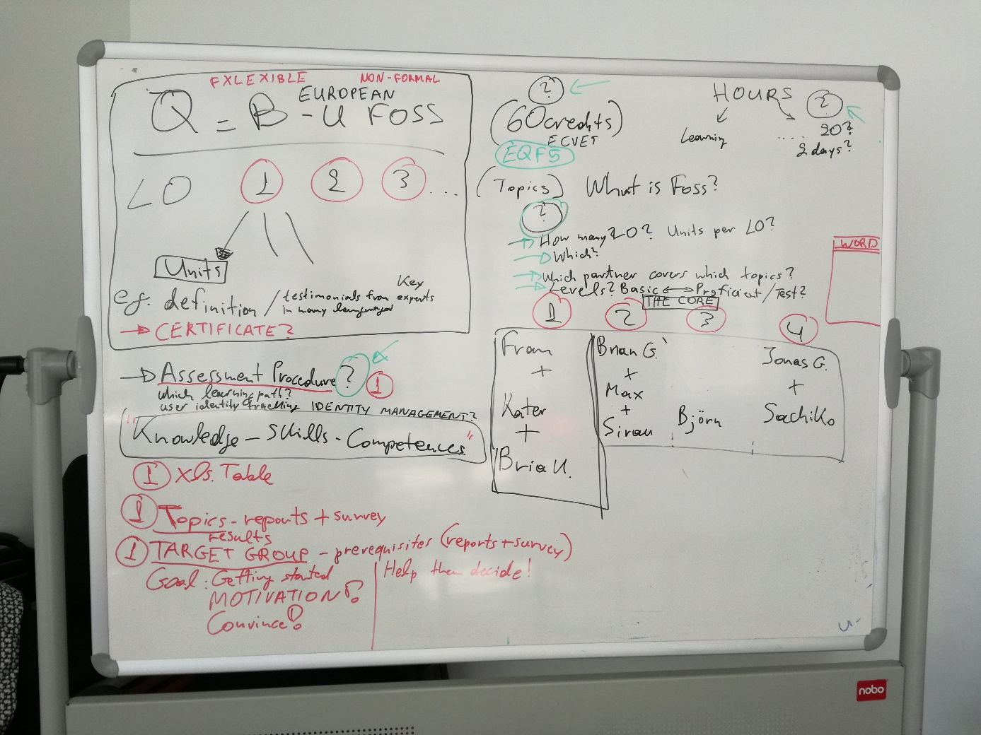

Team 2 worked on an online collaborative sheet. The team discussed:

………………… (please add your notes)

………………..

<https://theingots.org/community/sysml2u1x#1.1>

less formal: <https://www.udemy.com/how-you-can-save-thousands-with-free-open-source-software/>

on procurement: <https://www.gov.uk/government/publications/open-source-procurement-toolkit>

The results of Team 2 can be found here: <https://annuel2.framapad.org/p/foss4smes-content>

Also available in Keybase folder under the name: “FOSS4SMEs_Day2_Working session_Team 2_Proposed Curriculum”.

🡪 During the presentation of the results the project team checked if the topics identified in the country reports by team 1 (and also promised in the proposal) were matching the ones identified through team 2. The group was happy to see that this was the case.

🡪 DIT offered each team member the possibility to be filmed during the Dublin meeting and be part of a small section of the course.

🡪 The team agreed that it would be nice to have (famous) experts from all 6 participating countries talking about their experiences on FOSS in their native language. The rest of the content that is going to be developed can be translated (concerning the videos, the team discussed the use of subtitles).

🡪 Members of the team expressed their interests in developing certain learning outcomes. E.g. OFE wants to produce Module 3.

🡪 The team agreed that one partner will need to go through all modules to check them for consistency and adapt the content accordingly.

🡪 The Output Leader of O2 agreed to provide a methodology/reference framework in the beginning of July explaining the steps and timeframe for each partner concerning the tasks of the O2 which will last one year.

##### 11. Dissemination activities and Dissemination Plan

FSFE presented the 1st draft of the Dissemination Plan (no slides available)[9]. The team discussed:

* **The possible dates for the 4 multiplier events**: The 3 first should take place as stated in the proposal in May 2019, but the 4th should probably happen in August or September 2019 (as also stated in the proposal). Results of the discussion are seen in the following picture;
* The team clarified that the 4 multiplier events are different from other dissemination events. As a result, the Diss. Plan needs to be updated from FSFE concerning the types of events and their way of documentation in Keybase;
* **Concerning the documentation of dissemination events**, ATL presented an example of a Dissemination reporting table, that could be used by all team members, to keep track of all the “dissemination events” they participate in. ATL noted, that this is of very high importance for the National Agency and everything should be documented! Dlearn added, that the team needs a second sheet in the xls. table for the documentation of further “dissemination activities”. FSFE added that the team needs one more sheet for the “stakeholders’ matrix”, which is a database of contacts.

Action taken after the meeting:

ATL created a first table that the team can use in the shared Google Drive folder:

<https://docs.google.com/spreadsheets/d/1vgjD1UuzFo_sE-LAogX8lnk1g4pFC-AOo1NTQ4asl-U/edit#gid=6976930>

* **Concerning the project brochure**, that should be handed out in all events, ATL will prepare the required text and OFE offered to design a very modern template for the team. The team decided that a small leaflet opening from two sides would be nice to have, like the one FSFE showed;
* **Concerning the 4 newsletters**, that the team needs to produce, ATL presented an example from a previous project, showing that it can easily be done digitally. The team agreed that each partner will provide ATL with 3-4 sentences (pictures are welcome as well) describing in a lively but informative language their current working developments within the FOSS4SMEs project. For the 1st newsletter this needs to be done by the end of May.

Action taken after the meeting:

ATL created a document where the team can upload its text (Google Drive folder):

<https://docs.google.com/document/d/1U_pQ6H5vCYsAF7Ge4WWo9zB1m_XDld2vgsy9p4d81lI/edit>

* **Concerning our Twitter account,** ATL noted the importance of retweeting at least one message from the FOSS4SMEs account every month. All partners need to find who uses their organisation’s account and help with the use of this social media.
* **Concerning national dissemination plans**: that need to be developed by each partner, the team didn’t discuss any timeframe on this.
* **Concerning the 4th transnational meeting in Brussels**: the team discussed that it should probably happen at the same time with the Final International Conference that needs to be organized by OFE at the end of the project in Brussels. The idea is to travel only once to Brussels and stay for more days there. The team discussed that this should happen around 09.2019.
* **Concerning the IPR agreement**: which is basically about licensing and can have a length of one page, FSFE will prepare this by June 2018;
* **Concerning the Sustainability/Exploitation Plan mentioned in proposal page 68**: the team discussed that this should be a single document containing the Exploitation strategy, the Sustainability Statement/study and the Responsibility Matrix. No timeframe was agreed.
* **Concerning the Feasibility study**: OFE will prepare this document by June 2019.

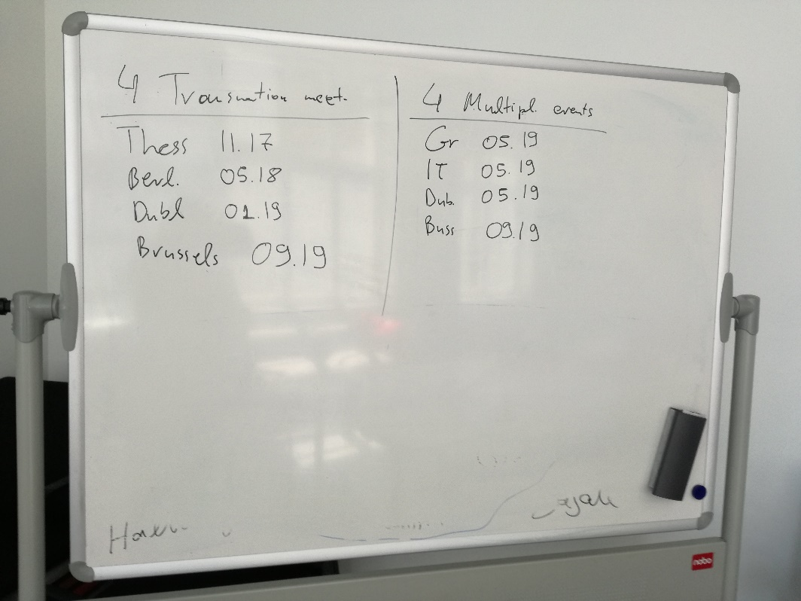

##### 12. Other points

1. The **evaluation of the Berlin meeting** will happen in the coming days via a digital questionnaire distributed from Dlearn to all team members.
2. Dlearn will produce a **single document** for O1/A2, that will include the Competence Profile, the Curriculum of the training course and the Assessment procedure for the recognition of competences until 06.18.
3. The team will need to envision **timeframes for content building** with the coordination of DIT.
4. A **potential risk** is how to find free artwork that makes our online content engaging.
5. There was no time left to discuss the updated **MCE Plan**, but we had the chance to update quickly some points in it. A new version will be uploaded in Keybase.

##### To dos list

|  |  |  |
| --- | --- | --- |
| **Action required** | **Partner** | **Deadline** |
| Fill in the evaluation survey of the Berlin-meeting, as part of our quality assessment activities:  <https://www.surveymonkey.com/r/DHKQD6D> | ALL | ASAP |
| Upload in Keybase presentations with the results of Output 1/A1 for your country (which were not shown due to time pressure). | Dlearn and FSFE | ASAP |
| Upload in Keybase the Powerpoint Presentation on the “1st Biannual Quality check results”. | Dlearn | ASAP |
| Upload in Keybase the presentation of the The ECVET Framework. | Dlearn | ASAP |
| Upload in Keybase the results of the big working session of team 1 during Day2. | Dlearn | ASAP |
| Prepare a small paragraph for the **1st Newsletter** (A11) under:  <https://docs.google.com/document/d/1U_pQ6H5vCYsAF7Ge4WWo9zB1m_XDld2vgsy9p4d81lI/edit> | ALL | 25.05.18 |
| Provide feedback on the **Project Website** style, design, shape etc. under: <https://docs.google.com/document/d/1BNsJZFTZLtp6QrfPSb3ejNSHR8SymntrOBQu0hdH1X4/edit>  And for the texts under:  <https://docs.google.com/spreadsheets/d/17fq4BltClOXPCkgLniytH1JnPegayLYwjYvjVbt99-Y/edit#gid=404477178> | ALL + Quality Manager | 28.05.18 |
| Update your information on the FOSS4SMEs **Contact details list**:  <https://docs.google.com/spreadsheets/d/1iqywfWAC3Oaoiq9zKG0hqdEotd_hRohjy6Je8ct0pLs/edit#gid=850553995> | ALL | 28.05.18 |
| Upload **photos** you took during our meeting in the folder: K:\team\foss4smes\Meetings\2. Berlin\Photos meeting | ALL | 28.05.18 |
| Discuss timeframe for the development of our **national dissemination plans** and update this information in the Dissemination Plan. | ALL | 28.05.18,Next teleconference |
| Discuss the timeframe for the preparation of the **Sustainability/Exploitation Plan**: Exploitation strategy, the Sustainability Statement/study and the Responsibility Matrix | FSFE | 28.05.18,Next teleconference |
| Check if the **Output description** in the timesheets should remain the same for the “manager” and the “technician” section or can be adjusted. | ATL | 31.05.18 |
| Check how to fill in the timesheet if the same person from one organisation is being the manager, the researcher and the technician. | ATL | 31.05.18 |
| Check if Sachiko can sign the timesheet twice, once as a project member and once as the supervisor. | ATL | 31.05.18 |
| Reach min. 20 replies in the survey. Finalise the Desk and Field Research Reports and update them in Keybase. | SKUNI, OFE, DIT | 31.05.18 |
| Decide the date for the **Dublin meeting**: 15-16 or 16-17.01.2019 | DIT | 06.18 |
| Prepare **document on O1/A2** concerning the Competence Profile, the Curriculum of the training course and the Assessment procedure for the recognition of competences. | Dlearn | 15.06.18 |
| **Peer Review** of Output 1 | DIT and SKUNI | 29.06.18 |
| Provide a **methodology framework** explaining the steps and timeframe for each partner within Output 2. | DIT | 13.07.18 |
| Update **Dissemination Plan (A7)** based on results of the meeting | FSFE | 07.18 |
| Prepare the **Quality Interim report** presenting results of both Quality Checks (will be uploaded in the Mobility Tool). | Dlearn | 07.09.18 |
| Prepare **IRP agreement** | FSFE | 06.18 |
| Prepare **Feasibility Study** | OFE | 06.19 |

1. Slides will be uploaded by Dlearn in Keybase.
2. See pptx file in Keybase, “FOSS4SMEs_Berlin meeting_ATL”.
3. See pdf file in Keybase, “FOSS4SMEs_Desk and Field research results_Berlin_DIT”.
4. See pdf file in Keybase, “FOSS4SMEs_O1-A1 UK report_OFE”.
5. Dlearn will upload the PPP in Keybase.
6. See pptx file in Keybase, “FOSS4SMEs_Blended Learning_DIT”.
7. <http://www.foss4smes.eu/>
8. Results of the work of team 1 will be uploaded in Keybase.
9. Check the document in Keybase here: K:\team\foss4smes\1. Management\A7 Dissemination Plan.