Table of Contents
INTRODUCING FOSS 2
1.1 Defining FOSS and the difference with proprietary software 4
1.1. Part 1 - A historical background 5
1.1. Part 2 - The guiding principles - The four freedoms 6
1.1. Part 3 - The definition of FOSS 7
1.1. Part 4 - The main differences between FOSS and proprietary software 8
1.1. Part 5 - The key players at transnational level 9
1.2 FOSS myths and types of freedom 11
1.2. Part 1 – Telling apart myths from facts 12
1.2. Part 2 - The different types of ‘freedom’ 13
1.2. Part 3 – Great reasons for using FOSS tools 14
1.2. Part 4 – Are there any disadvantages? 15
1.3 Rights, licensing and responsibilities 17
1.3. Part 1 - Issues related to user rights 18
1.3. Part 2 - Ownership and licencing 19
1.3. Part 3 – Choosing the necessary licence for a business 20
1.3. Part 4 – Responsibilities of FOSS users 21
1.4 FOSS communities and their ways of collaboration 23
1.4. Part 1 – Finding a FOSS community 24
1.4. Part 2 - The main FOSS communities in national and international level 25
1.4. Part 3 - How members of FOSS communities communicate and collaborate at local, national and transnational level 26

Unit 1

INTRODUCING FOSS
Introductory text explaining what the unit is about. This should include a description of the content type, the major lesson consents and associated quiz. [approximately 600 characters]
Within Unit 1, we will explore the following:
- in Lesson 1 the definition of ‘Free and Open Source Software’ (FOSS) and the main differences from proprietary software;
- in Lesson 2 the types of freedom related to FOSS, discerning between facts and myths related to FOSS theory and applications;
- in Lesson 3 the issues related to licensing, user rights, ownership and responsibilities of FOSS users;
- in Lesson 4 the ways to find relevant FOSS communities, the main communities in the world as well as their ways of collaboration.

Bibliography relevant for Unit 1:

FSFE (2018): Free Software. URL: https://fsfe.org/freesoftware/basics/summary.en.html

FSF (2018): What is free software? URL: https://www.gnu.org/philosophy/free-sw.html

FSF (1986): GNU'S BULLETIN Volume 1, No.1. URL: https://www.gnu.org/bulletins/bull1.txt

González-Barahona, J. (2004): Quo vadis, libre software? v0.8.1, work in progress, 14 September. URL: https://archive.li/MgicZ (accessed 7 December, 2018)

Björn Schießle (2012): Free Software, Open Source, FOSS, FLOSS - same same but different. URL: https://fsfe.org/freesoftware/basics/comparison.html

Karl Fogel (2005-2017): Producing Open Source Software: How to Run a Successful Free Software Project, O'Reilly Media.

Richard Stallman: FLOSS and FOSS. URL: https://www.gnu.org/philosophy/floss-and-foss.html

David Crooke (2018): Open Source vs. Proprietary Software. URL: https://www.greennet.org.uk/support/open-source-vs-proprietary-software

Richard Stallman: Free Software Is Even More Important Now. URL: https://www.gnu.org/philosophy/free-software-even-more-important.en.html

The Free Software Directory: https://directory.fsf.org/wiki/Main_Page

Benjamin Mako Hill: When Free Software Isn't (Practically) Superior. URL: https://www.gnu.org/philosophy/when-free-software-isnt-practically-superior.html

Ben Bromhead (2017): 10 advantages of open source for the enterprise. URL: https://opensource.com/article/17/8/enterprise-open-source-advantages

Rachel Bridge (2018): Open source software: Advantages & disadvantages. URL:
https://entrepreneurhandbook.co.uk/open-source-software/

Wikipedia: Software license. URL: https://en.wikipedia.org/wiki/Software_license

Richard Stallman: The Free Software Community After 20 Years: With great but incomplete success, what now? URL: https://www.gnu.org/philosophy/use-free-software.en.html

The Linux Foundation: Participating in Open Source Communities. URL: https://www.linuxfoundation.org/resources/open-source-guides/participating-open-source-communities/

Brian Gentile (2011): The responsibility in open source. URL: https://opensource.com/business/11/7/responsibility-open-source

Elizabeth Tatham (2013): Roles in open source projects. URL: http://oss-watch.ac.uk/resources/rolesinopensource

CeBIT Australia (2018): 3 open source communities with the most active user participation. URL: http://blog.cebit.com.au/open-source-communities

Jenni McKinnon (2017): A Citizen’s Guide to Open Source Communities. URL: https://pagely.com/blog/citizen-guide-open-source-community/

Lessons

1.1 Defining FOSS and the difference with proprietary software

Introduction:
The European Commission has launched the Digital Agenda for Europe, which proposes to better exploit the potential of ICT -including FOSS- in order to foster innovation, economic growth and progress, pointing out the need to promote the digital skills of the European workforce. The use of FOSS will bring several benefits to European SMEs and will particularly improve their digital performances and competitiveness.

In this lesson we will explore the following:
- What is the concept behind the definition of FOSS?
- What are the guiding principles/ the four freedoms?
- What are the main differences between FOSS and proprietary software?
- Which are the key players involved in this field at national and transnational level?

1.1. Part 1 - A historical background

As stated by Unni “the origins of open source software can be traced back to 1964–65 when Bell Labs joined hands with the Massachusetts Institute of Technology (MIT) and General Electric (GE) to work on the development of MULTICS for creating a dynamic, modular computer system capable of supporting hundreds of users. During the early stages of development, open source software had a very slow beginning primarily because of some preconceived notions surrounding it” (Unni, 2016, p. 271).

In 1983 these ideas were revitalised from the Free Software movement initiated by Richard Stallman, who inaugurated the GNU project. This is an operating system created by experts working for the freedom of all users and based on the idea that everyone should have full control over their own software. Stallman realised from the start, that access to a software's source code was a prerequisite to make it 100% free. The struggle for Free Software has just began.
Image source: https://www.gnu.org/graphics/gnu-head-sm.jpg

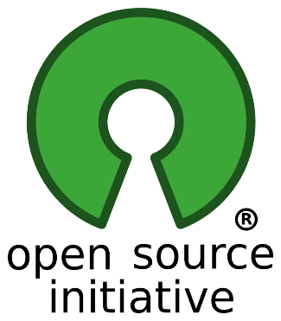
In 1997 the “Debian project” wanted to create a completely free operating system (GNU/Linux distribution) and the company Netscape wanted to release a browser as FOSS. Within these developments, a team was created based in Silicon Valley and started intensively campaigning for FOSS and used for the first time the term “Open Source Software”. The new term aimed to clarify the difference between this and software that was just free of charge. The team wanted fast commercialisation and acceptance of FOSS by companies and the booming economy and decided not only to leave aside the terminology issues - as these seemed to be against the wider acceptance-, but also to focus on the technical advantages. The team was then called the Open Source Initiative (OSI) and is today a non-profit corporation with global scope. OSI is now educating about and advocating for the benefits of open source and is also building bridges among different constituencies in the open source community.
Image source: https://opensource.org/logo-usage-guidelines

In the beginning of the 90s the term “Libre Software” was popularised. This term, which was mainly used in the Spanish speaking communities, influenced a research project named FLOSS and was also used by the European Commission since their involvement with FOSS on a regular basis. The ambiguity of the English word "Free Software" and the misunderstandings of the term "Open Source" were now being avoided through the adoption of a term that clearly talks about freedom and not money and still used in an identical way to FOSS.

More information on the different terms can be found at: https://www.gnu.org/philosophy/open-source-misses-the-point.html

1.1. Part 2 - The guiding principles - The four freedoms

Speaking about FOSS is speaking about freedom. For example, think of the freedom to give away your recipe or to allow your friends to improve it. In a similar way, FOSS can be given to other people, who can use it or improve it. If you think that with FOSS you need to know about programming, you are mistaken. If you ever need help, the so called “freedoms” of FOSS give you among other things the possibility to ask for solutions from people who can program for the whole community. The only precondition is that they have access to the source code - otherwise, it is impossible.
Image Source: https://www.pexels.com/photo/adult-background-beach-blue-296282/

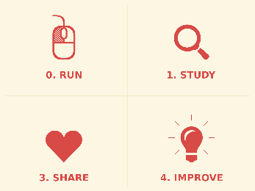
The four freedoms of FOSS are 1. the unlimited use of software for any purpose; 2. the right to study how the program works and understand it. Access to the source code is a precondition for this; 3. the right to share copies of the software and hereby to help other people and 4. the freedom to improve the program and to distribute the improvements to the program, so that everybody profits from it. Access to the source code is a precondition for this.
Image Source: https://openclipart.org/detail/256647/four-freedoms-of-free-software-redux

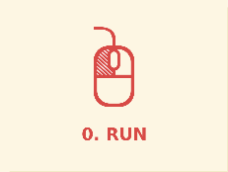
1. The freedom to run the program means the freedom for any kind of person or organization to use it on any kind of computer system, for any kind of overall job and purpose, without being required to communicate about it with the developer or any other specific entity. It is the user's purpose that matters, not the developer's purpose.

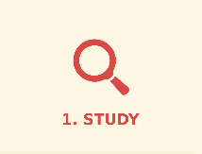
2. The freedom to study the source code and make changes includes the freedom to use your changed version in place of the original.

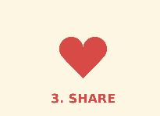
3. The freedom to redistribute if you wish means you are free to redistribute copies, either with or without modifications, either gratis or charging a fee for distribution, to anyone anywhere, without having to ask or pay for permission to do so. If you do publish your modifications, you should not be required to notify anyone in particular, or in any particular way.

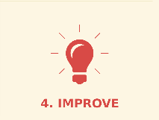
4. The freedom to distribute copies of your modified versions to others includes the freedom to release your modified versions as FOSS. If the program is delivered in a product designed to run someone else's modified versions but refuses to run with your modifications, then it’s not FOSS even if the source code is free. Further, if you modify a program by merging in available free subroutines or modules and the license doesn’t allow the merger along with a similar licence (see lesson 3), but requires non-free licencing, then the license is too restrictive and the software is not free.

1.1. Part 3 - The definition of FOSS
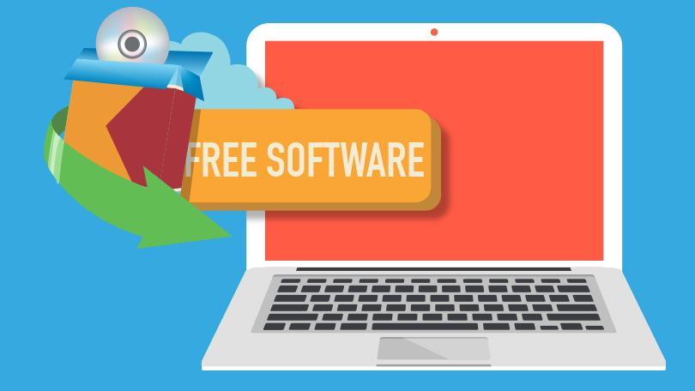
There is a variety of terms that are used to define “Free Software”. Historically seen, there are two political camps in the free software community that formed the development of the term. On the one hand the “free software movement” of FSF is a campaign for users' freedom and considers non-free programs an injustice to the users. While on the other hand the “open source camp” of OSI declines to see the issue as a matter of justice and bases its arguments on practical benefits only.
Image source: https://www.pcmag.com/article2/0,2817,2487049,00.asp

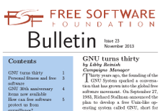
“Free Software” was the first term and it was first documented in the magazine GNU's Bulletin, vol. 1 no. 1 of February 1986. This specific term is today officially preferred by the Free Software Foundation Europe (FSFE) as well as by the GNU Operating System (GNU). On the contrary, the term "Open Source Software", which was originally defined to mean the same thing as Free Software in terms of licenses and implementation, was first used in 1998 by the Open Source Initiative (OSI). Today there are companies that prefer and use one or the other term. In practicality there are no differences as both terms mean the same.
Image source: https://www.fsf.org/blogs/community/fall-2013-fsf-bulletin-now-available-online

A third term evoked by a researcher studying practices and methods used by developers in the FOSS community. He decided that the terminology should not rely on the developers' political views and so he used the term “FLOSS”. FLOSS means “Free/Libre and Open Source Software” and was introduced as the name of a research project by Ghosh back in 2000.
Image source: https://www.pexels.com/photo/blur-close-up-code-computer-546819/

The rest of the terms, like “FOSS” -which stands for “Free and Open Source Software”-, "organic software" or "ethical software", are further additions to the terminology debate and tend to cause confusion as they virtually invite people to look for differences that actually don’t exist.

Further information can be found at:
https://opensource.com/article/17/11/open-source-or-free-software

1.1. Part 4 - The main differences between FOSS and proprietary software

A common misbelief is that "FOSS" means "zero-cost software". It is a fact, that FOSS can be distributed free of charge, but its main difference to proprietary software is that it is free to be used, studied, shared and modified by anyone under the terms of its license. On the contrary, users of proprietary software are not allowed to copy neither to distribute their software, as this forms an illegal action.
Image source: https://www.pexels.com/photo/photo-of-green-data-matrix-1089438/


A second difference is the following situation concerning the amount of control we have over our own programs. At “non-free” or “proprietary” the program (and its developers) controls the users, making it an instrument of unjust and manipulative power. There might be functionalities designed to mistreat, spy on, censor or even restrict the users along with unforeseen limitations and other unwelcome surprises. The opposite applies for FOSS, where users control the program, both individually and collectively.
Image source: https://www.pexels.com/photo/food-colorful-sweet-bear-54633/
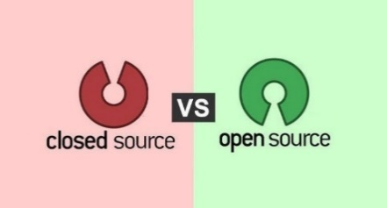
The third difference has to do with licencing. Proprietary or closed-source programs are the opposite of "free" or "open source". This is because they are distributed under traditional, royalty-based licensing terms, where users pay per copy, or under any other terms sufficiently restrictive to prevent open source dynamics from operating. On the other hand, FOSS can be used without paying a license fee, and anyone can modify the software.

A further important point to keep in mind is that the source code of proprietary software is usually a closely guarded secret, whereas by FOSS it is freely available.

Examples
Category | Proprietary | FOSS
Office application package | MS Office | Libre Office, Open Office
Operating System | MS Windows, MAC OS | GNU/Linux
Web browser | Microsoft Internet Explorer | Mozilla Firefox
Telephony over internet | Skype | Ekiga, Empathy
Compressing/decompressing files | winzip | 7-zip
Multimedia Players | Winamp, Windows Media Player, QuickTime | VLC, Audacious, Clementine

1.1. Part 5 - The key players at transnational level
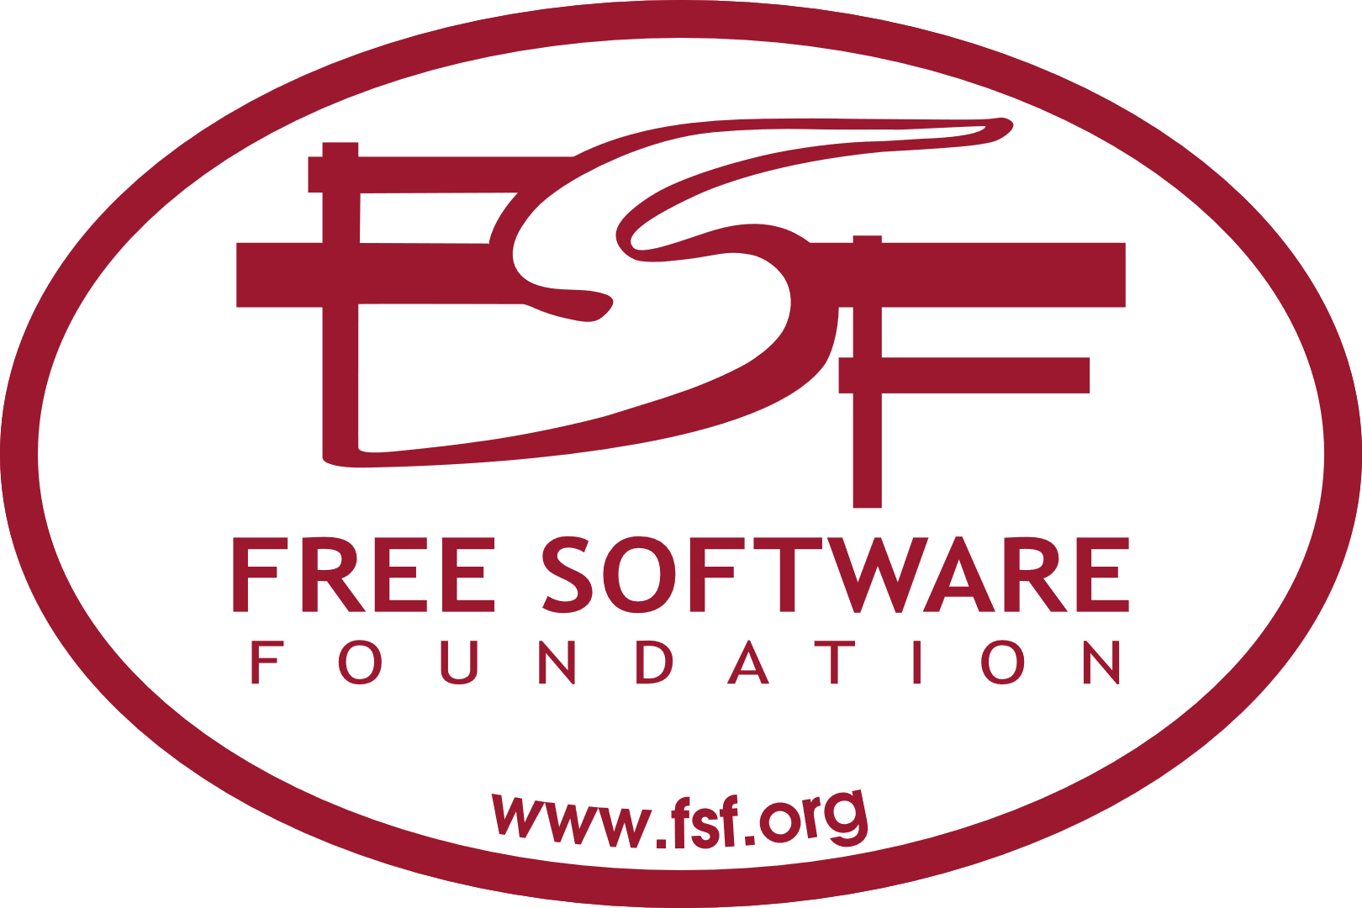
The Free Software Foundation (FSF) is a non-profit organisation with a worldwide mission to promote computer user freedom by promoting the development and use of free (as in freedom) software and documentation and by campaigning against threats to computer user freedom. It also provides important resources to the community including the FSF/UNESCO free software directory. See further: : https://www.fsf.org/
Image source: https://www.fsf.org/resources/stickers

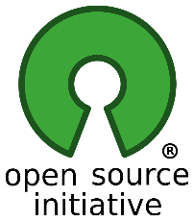
The Open Source Initiative (OSI): The OSI is a non-profit corporation with global scope formed to educate about and advocate for the benefits of open source and to build bridges among different constituencies in the open source community. It also approves licences of Open Source Software. See further: www.opensource.org
Image source: https://opensource.org/logo-usage-guidelines

Libre Office – The Document Foundation: LibreOffice is community-driven FOSS and a project of the non-profit organisation “The Document Foundation”. LibreOffice, originally based on OpenOffice.org (known as OpenOffice) is the most actively developed OpenOffice.org successor project. More at: https://www.libreoffice.org/about-us/who-are-we/
Image source: http://www.libreoffice.org/


Free Software Foundation Europe (FSFE) is a charity that empowers users to control technology. It helps individuals and organisations to understand how Free Software contributes to freedom, transparency, and self-determination and enhances users' rights by abolishing barriers to Free Software adoption. It also encourages people to use and develop FOSS and provides resources to enable everyone to further promote Free Software in Europe. More at: https://fsfe.org/about/about.en.html
Image source: https://fsfe.org/contribute/getyourgraphic.en.html


The European Commission puts efforts in the promotion of FOSS. Since 2000 there is a strategy on the use of FOSS, updated now to the Action Plan 2014-2017, which proposes to adopt their use formally. The EU promotes FOSS within Member States, it has created the first FOSS license available in 22 languages and open to anyone and has also launched the Open Source Observatory. More at: https://ec.europa.eu/info/departments/informatics/open-source-software-strategy_en
Image source: https://www.pexels.com/photo/blue-and-yellow-round-star-print-textile-113885/

A list of Organizations that work for freedom in computer development and electronic communications can be found at https://www.gnu.org/links/links.html#FreedomOrganizations

Assessment

Are you ready to say what FOSS is?

(free text answer)

The abbreviation ‘FOSS’ means: …………………………………………………………..
Correct answer is: Free and Open Source Software
Check all that apply

Which are the guiding principles of FOSS?
the freedom to use
the freedom to study
the freedom to share
the freedom to sell the software
the freedom to change the software in any way

The main differences between FOSS and proprietary software concern:
Licencing
Source code
market price
Amount of control by the users
their business use

(False/True Statements)

Proprietary software typically allows users to copy and distribute the software.

1 True 2 False

The use of FOSS is promoted and supported by the European Commission and the governments of some Member countries in many different ways.

1 True 2 False

Famous examples of FOSS tools are Microsoft Office, Windows Media Player and Google Chrome Internet Browser.

1 True 2 False

Summary

FOSS exists since the 80’s and is based on four freedoms/guiding principles: the freedom to use, study, share and change/improve a software in any way, as the source code is open. There is a variety of terms that are used to define FOSS, which all basically mean the same thing. The main difference between proprietary software and FOSS is that with proprietary software users are not allowed to copy neither to distribute the software. Famous examples of FOSS are OpenOffice/LibreOffice, GNU/Linux, Mozilla Firefox and VLC. Many organisations are promoting the use of FOSS worldwide, like for instance the FSF, the OSI, the Document Foundation, FSFE and the European Commission itself.

1.2 FOSS myths and types of freedom

Introduction:
There are many myths about FOSS being not secure or coming with no technical assistance. These misleading perceptions have been holding users away from FOSS tools for a long time now. In this lesson we discern between facts and myths and describe how things really look like in the FOSS world.

In this lesson we will explore the following:
- How can we tell apart myths from facts?
- Which are the different types of ‘freedom’ implied in the FOSS concept?
- Which are the greatest reasons for using FOSS?
- Are there any disadvantages when using FOSS tools?

1.2. Part 1 –Telling apart myths from facts


Myth1: “FOSS is less secure since the source code of a software is publicly available”: Source code that is openly accessible and published can be checked by independent parties for security loopholes or installed backdoors, which is a trust-gaining measure.
Image source: https://www.pexels.com/search/support/

Myth 2: “No professional technical support available with FOSS”: Many FOSS companies have specialised in support-services for FOSS users.
Myth 3: “Low Compatibility of FOSS with other/proprietary software”: FOSS can be complementary to other/proprietary software, as it can be modified to run both well on Windows, Apple or Linux. Prominent examples are the Firefox Browser, Libre Office or the VLC Media Player.


Myth 4: “FOSS is not very reliable, because it is always developed by amateurs/hobbyists”: Many different individuals and companies contribute code, and many highly paid IT-professionals are working in large companies that invest millions of Euros in FOSS development and code improvement. Around 90% of the contributions to Linux come from professional developers employed by different companies.
Image source: https://www.pexels.com/photo/city-blue-building-construction-41170/

Myth 5: “FOSS is in general less user friendly”: Different FOSS is developed for different kinds of users and usage contexts. For example, a Command Line Interface (CLI) can be an effective and proper user interface for a programmer, while a Graphical User Interface (GUI) can be suitable for an office user, e.g. such as the one provided by Mozilla Firefox. Other examples are the Android operating system for smartphones, the most modern TV screens, Wikipedia and web publication tools like WordPress, Drupal or Typo3, which are FOSS or include FOSS components as well.

Myth 6: “FOSS is only a trend and you can’t rely on it for the future”: FOSS is actually a long-term success story, since almost all software prior to the 1980s was FOSS. Since then, a constantly growing number of individuals, businesses and institutions use and contribute to FOSS.


Myth 7: “FOSS means “non-commercial””: FOSS must be available for commercial use, development, and distribution. Regardless of how users get their copies (paid or free of charge), they always have the freedom to sell copies and if a FOSS program doesn’t allow this, it is not FOSS.
Image source: https://www.pexels.com/photo/airport-bank-board-business-534216/

1.2. Part 2 - The different types of ‘freedom’

Tipp from Brian K.:
1: The implied freedom which might be extended to using software within FOSS software. i.e should that freedom be extended.
2. The implication that the software is "free of charge" which is not correct
(I still need help to draft this – sources are needed)

Ways on how a business user can assess the type of freedom related to a FOSS tool and decide which tool is necessary for him/her.
Should be covered according to the curriculum, But Sources are needed.

1.2. Part 3 – Great reasons for using FOSS tools


Any piece of FOSS that respects users' freedom has a strong inherent advantage over a proprietary competitor that does not. Even if it has other issues, FOSS always has freedom. The following list includes the potential benefits of using FOSS in a compact and simplistic way, but it’s important to remember that benefits are highly context-dependent and apply in different extends.

Potential benefits of using FOSS include:
- the development of digital skills;
- improved software quality created by the collective power of talented community members;
- the ability to customise software for own usage;
- fair competition in the software-market;
- protection of privacy;
- increasing stability (especially in regard to malware);
- decreasing software costs as FOSS require no licensing fees;
- increasing security because it is much more thoroughly reviewed and vetted by the community;
- long-term sustainability of software with quicker development and troubleshooting by the powerful community when issues arise;
- increasing reliability since more eyes are on FOSS, the source code tends to be superior and the output very robust;
- companies and users have more control over their own hardware devices, own IT systems and associated digital artefacts;
- that global and united communities are improving FOSS by often introducing new concepts and capabilities faster, better, and more effectively;
- freedom from vendor-lock in, meaning that there is no more the risk of becoming locked in by the vendor or technology and then be at the mercy of vendors' price increases and experience a lack of flexibility you can't easily and readily escape.

Image source: https://www.pexels.com/photo/man-in-red-crew-neck-sweatshirt-photography-941693/

Video on advantages for SMEs (“What's In It for Me? Benefits from Open Sourcing Code - Open Source Developers @ Google Speaker Series: Ben Collins-Sussman and Brian Fitzpatrick”, 25.10.2007): https://www.youtube.com/watch?v=ZtYJoatnHb8

Image source: https://www.pexels.com/photo/photo-of-woman-using-her-laptop-935756/

1.2. Part 4 – Are there any disadvantages?

As any other software, FOSS may lack expected functionality and provide limited features. It may be that specific FOSS may fail to fulfil expectations in a specific use case, because the licence itself doesn’t make the software better. However, anyone can reuse the source code of FOSS and improve it and anyone can also procure (and pay someone else) to improve specific FOSS so that it fulfils expectations, so the probability of FOSS being the better choice is higher than with proprietary software.

It’s not widely spoken, but any developer or user of an early-stage FOSS project or tool can explain that FOSS is not always as convenient, in purely practical terms, as its proprietary competitors. It can be sometimes of low quality, unreliable or inflexible. There are many people that truly believe in the power and the future of FOSS, but they find it hard to explain why FOSS has not fulfilled its “promises”. It is a fact that proprietary tools can be sometimes a better choice and there is no reason that users should explain themselves.
Image source: https://www.pexels.com/photo/slippery-foot-dangerous-fall-36763/

Richard Stallman speaks to this in his article on Why Open Source Misses the Point when he explains, that “the idea of open source is that allowing users to change and redistribute the software will make it more powerful and reliable. But this is not guaranteed. Developers of proprietary software are not necessarily incompetent. Sometimes they produce a program that is powerful and reliable, even though it does not respect the users' freedom.” Image source: https://www.pexels.com/photo/selective-focus-photography-of-falcon-1619227/


Furthermore, the vast majority of FOSS projects are at no technical advantage with respect to a proprietary competitor. Because there is no requirement to create a commercial product that will sell and generate money, FOSS solutions can tend to evolve more in line with the developers’ wishes than the needs of the end-user. For the same reason, they can be less “user-friendly” and not as easy to use because less attention is paid to developing the user interface. There may also be less support available for when things go wrong.
Image source: https://www.pexels.com/photo/photo-of-person-typing-on-computer-keyboard-735911/

Although having an open system means that there are many people identifying bugs and fixing them, it also means that malicious users can potentially view it and exploit any vulnerabilities. Because of the way it has been developed, FOSS can require more technical know-how than proprietary systems, so users may need to put time and effort into training themselves or their colleagues/employees to the level required to use it.
Image source: https://www.pexels.com/photo/ballpen-blur-close-up-computer-461077/

Assessment

Are you ready to discern between facts and myths?

(Matching Text)

FOSS respects… → users' freedom.

With FOSS tools, companies and users have… → more control over their own hardware devices and IT systems.

It is not guaranteed… → that allowing users to change and redistribute a software will make it more powerful and reliable.

Check all that apply

FOSS is developed by:
1 hobbyists
2 only unpaid IT-experts
3 certain private companies only
4 only by IT university students
5 highly paid IT-professionals and companies

FOSS:
1 is a long-term success story
2 exists only recently as a trend
3 was first seen after the 80s
4 has been developed even prior to the 80s
5 is not sustainable

(False/True Statements)
In order to use FOSS, you need to be an IT-expert.

1 True 2 False

In order to contribute to the FOSS community, you need to be an IT-expert.

1 True 2 False

FOSS can require more technical know-how than proprietary systems.
1 True 2 False

Summary

There are many myths about FOSS being not secure or coming with no professional technical support. These misleading perceptions should not hold users away from FOSS tools, as there are many great reasons for using FOSS, like for instance, the ability to customise the software, the protection of privacy, the decreased software costs or the increasing security. On the other hand, FOSS can require more IT know-how from its users, so they may need to put time and effort into training themselves or their colleagues/employees to the level required to use it efficiently.

1.3 Rights, licensing and responsibilities

Introduction:
When we use, study, share or improve a software, it is important to be aware of its licence, our rights as software users and our responsibilities to the developing community. Licences are affecting our lives giving us not only rights on a software, but also responsibilities. In this lesson we will understand the main implications on licencing and will give them practical application.

In this lesson we will explore the following:
- Which are the rights obtained by a FOSS software user?
- What are the issues related to licensing and copyright?
- Which are the FOSS licences?
- Which are the responsibilities of FOSS users?

1.3. Part 1 - Issues related to user rights


The main difference between proprietary software and FOSS is the granting of rights to modify and re-use a software product obtained by a user. FOSS software gives both rights to a user and bundles the source code with the software. On the contrary, proprietary software typically does not license these rights and therefore keeps the source code hidden or restricts one of the other four freedoms.
Image source: https://www.pexels.com/photo/adult-agreement-blur-brainstorming-630839/

In addition to granting rights and imposing restrictions on the use of copyrighted software, licenses typically contain provisions which allocate liability and responsibility between the parties entering into the license agreement (end-users and companies). In proprietary software transactions, these terms often include limitations of liability, warranties and warranty disclaimers, and indemnity if the software infringes intellectual property rights of anyone.

Unlicensed software is either public domain software or software which is non-distributed, non-licensed and is handled as internal business trade secret.

When unlicensed software is being distributed, it is then fully copyright protected. This means, that it is therefore legally unusable (as no usage rights at all are granted by a license) until it passes into the public domain after the copyright term has expired. As voluntarily handing software into the public domain (before reaching the copyright term) is problematic in some international law domains (for instance the Law of Germany), there are also licenses granting PD-like rights, for instance the CC0 (which is typically used for content) or WTFPL.
Image source: https://www.pexels.com/photo/mountains-nature-arrow-guide-66100/

1.3. Part 2 - Ownership and licencing

Selling is allowed
Concerning the ownership rights of a user, keep in mind that a copyright holder cannot oppose the resale of a digitally sold software. According to the Law, ownership is transferred and users can sale such software, like for example the EU Directive 2009/24/EC expressly permits trading of used computer programs.


Ownership remains with the publisher
At proprietary software licenses the software publisher grants the use of one or more copies under the end-user license agreement (EULA), but the ownership of those copies remains with the software publisher. This means that certain rights are reserved by the publisher, for instance the number of installations allowed or the terms of distribution. As a result, the end-user has no alternative but to accept them, since without it s/he may not be able to use the software at all.
Image source: https://www.pexels.com/photo/person-holding-white-paper-and-typewriter-1043512/


FOSS licences
To make a newly developed software FOSS, it is necessary to release it under a FOSS license. There are three widely recognized entities that regularly evaluate licenses: 1. The Free Software Foundation, 2. the Debian project and 3. the Open Source Initiative. To decide whether a specific license qualifies as FOSS license, licensing experts review a licence and its conditions and judge it based on specific criteria (frequently updated) to determine whether it fits their spirit as well as the precise words. If a license includes unconscionable restrictions, it is rejected.
Image source: https://www.pexels.com/photo/beautiful-sky-875858/


Copyleft vs Permissive licences
FOSS licenses can be categorised into copyleft (found also as protective share-alike) and permissive licenses (found also as non-protective or non-copyleft). Copyleft licenses are designed to protect the rights to use, study, share and improve the software and require that those freedoms apply to any derivative works. Permissive licenses allow to distribute the software without those rights and have minimal requirements about how the software can be redistributed while they don’t have a clause requiring that they apply to derivative works as well.
Image source: https://www.pexels.com/photo/close-up-photo-of-keyboard-220357/

A list of different free and non-free licences can be found at:
https://www.gnu.org/licenses/license-list.html
and https://spdx.org/licenses/ and https://opensource.org/licenses

1.3. Part 3 – Choosing the necessary licence for a business

1.3. Part 4 – Responsibilities of FOSS users

Why contribute?
Some users (can be community members) use FOSS and do not contribute back in any recent or relevant way to the FOSS community and its projects. In fact, it is expected that if someone benefits from the value through the use of a FOSS tool/project, then s/he should contribute back to the community in any way s/he can (by donating time or money). This is what is called “the responsibility of a FOSS user”. Users should feel responsible for the continuation and the success of a FOSS community or a tool they use. Either voluntarily or when asked they should participate and collaborate.
Image source: https://www.pexels.com/photo/brown-wooden-cubes-944773/

Project Leadership
FOSS project leaders have an on-going responsibility to make it easier for community members to contribute by planning these steps efficiently. If a project has significant participation rates, then members and users feel responsible to support a growing, vibrant community. Contribution, participation, collaboration and transparency are the key-factors to reach a state where each member embodies the principles of FOSS and altogether achieve something great.
Image source: https://www.pexels.com/photo/person-standing-on-slope-glacier-mountain-1081111/


Participating in a FOSS community is intimidating, but as communities are composed of people, new members should be aware that they will meet both virtues and foibles of existing members. Important is to support a common goal with your available skills giving your best effort. Newcomers should therefore take the time to plan their involvement by visiting first the project’s/the community’s website, where guidelines are usually provided.
Image source: https://www.pexels.com/photo/close-up-photography-of-yellow-green-red-and-brown-plastic-cones-on-white-lined-surface-163064/

Do I need to be an IT-expert?
Not all users need to be IT-developers to contribute to a FOSS project/community. Many tasks and things like the code, the documentation or even the artwork of a project are being created, tested and refined by non-IT-skilled members. Some of the processes that one could get involved with are: providing feedback, recommending the project to others, testing or requesting new features, creating artwork, writing or updating documentation or even translating. The roles commonly used are: leaders, maintainers, committers, contributors and users.

Assessment

Are you ready to say how licencing applies at FOSS products?

(Fill in the blank)

Unlicensed software is either public domain software or software which is non-distributed, non-licensed and is handled as internal business trade secret. When unlicensed software (not in the PD) is being distributed, it is then fully copyright protected. This means, that it is therefore legally unusable (as no usage rights at all are granted by a license) until it passes into the public domain after the copyright term has expired.

Multiple Choice

The selling or reselling of FOSS software:
is not allowed
is always allowed
is allowed under certain circumstances
is prohibited for FOSS companies, like Mozilla

Newly developed software is only free:
when it is released under a non-free licence
when it is called “open source software” in a website
when it is released under a FOSS license
when the source code is closed

(Definitions)

Copyleft licenses → are designed to protect the rights to use, study, share and improve the software.

Non-protective licenses → allow to distribute the software as proprietary software or to bundle it together with proprietary software.

Protective share-alike licenses → require that the ‘four freedoms’ apply to any derivative works.

Permissive or non-copyleft licenses → have minimal requirements about how the software can be redistributed, while they don’t have a clause requiring that they apply to derivative works as well.

Summary

FOSS software gives both rights to a user and bundles the source code with the software. Unlicensed software is either public domain software or software which is non-distributed, non-licensed and is handled as internal business trade secret. Unlicensed software is always fully copyright protected. The selling or reselling of FOSS software is allowed. Newly developed software is only free, if it is released under a FOSS license. FOSS licenses are roughly dividableinto 2 categories: a) Copyleft licenses and 2) permissive licenses. FOSS users are welcome to contribute back to the communities that developed the tools they use and feel responsible for the continuation and success of them.

1.4 FOSS communities and their ways of collaboration

Introduction:
FOSS communities and their members have developed interesting ways of collaborating with each other across the globe. They are supported not only by their users, but also from bigger foundations or organisations. New users and ITexperts wanting to contribute will find a number of ways to participate in these exciting groups. The most famous ones are The WordPress-, the Moodle-, the Github- and the Drupal-community.

In this lesson we will explore the following:
- How can we find a relevant FOSS community?
- Which are the main FOSS communities in national and international level?
- How do the members of FOSS communities communicate and collaborate at local, national and transnational level?

1.4. Part 1 – Finding a FOSS community


FOSS communities
FOSS communities often are diverse and highly motivated groups of developers and end-users. They sometimes are supported by initiatives, foundations or associations to contribute to a common effort, to maintain communication with each other and to efficiently organise themselves. As private companies (like Intel, IBM or Samsung) use open source code to build their own commercial products and services, they also see a strategic value in contributing back to those projects and support such communities as well. Today there is a large community of users who run GNU/Linux and other FOSS and there are even more people, who would like to extend this work, and who try to convince more users to use FOSS. Since 2005, over 13,500 developers from over 1,300 different companies have contributed only to the Linux kernel project.
Image source: https://www.pexels.com/photo/photo-of-four-persons-uniting-hands-943630/

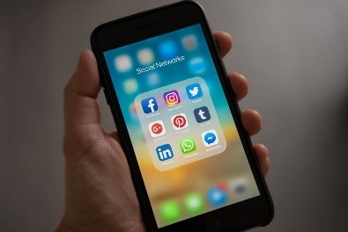
Finding a community
It is possible to find someone to either get or give help to no matter what your interests are. Looking across Social Media pages like Facebook, Twitter, Google+, LinkedIn or Reddit, there are numerous official and unofficial accounts that share each community's news and views. This is an easy way to find all relevant international or national communities of Wordpress, Joomla, NextCloud, OwnCloud, Drupal, Mozilla or the Software Libre Society simply by looking for them with your internet search engine.
Image source: https://www.pexels.com/photo/apple-applications-apps-cell-phone-607812/

Becoming member of a community and getting in contact

There are a lot of ways to contact members of the community and get involved by contributing to the development of new tools and exciting solutions. The first time it may be overwhelming or scary, but soon enough users realise how welcoming a community can be. Sometimes members come from very different countries and will probably never meet each other, but they often have a lot of fun and enjoy volunteering or helping each other.
Image source: https://www.pexels.com/photo/woman-wearing-white-top-holding-smartphone-and-tablet-864994/

Establishing collaboration with the most relevant communities (for SMEs)
If an SME is new to FOSS, it should be considered to hire someone who has already collaborated with a FOSS community, so they can provide guidance to the SME concerning how to both contribute and gain the most from such communities. Experienced contributors can act as mentors and help SME employees pursue the FOSS pathway. The ways in which an SME can establish new collaborations with relevant communities vary from project to project.

1.4. Part 2 - Some large FOSS communities in national and international level

WordPress is a massive community powering over 30% of the web. The platform that was at first a blogging space has now mapping, video and enterprise commerce capability. 500 sites are created daily, and over 47,000 plugins are developed. The success is its community, who is very active from day 1. Wordpress has a really great structure, allowing for 14 ways to contribute to it. The diverse community includes not just developers, but bloggers and business owners, so there is feedback on many levels, creating a satisfying user experience.
Image source: https://www.pexels.com/photo/blogging-blur-business-communication-261662/

Moodle is a widely used Learning Management Software space, primarily concerned with e-learning and training, that is used by many universities around the world. It has won the attention of large organisations like Cisco and IBM and has a range of useful features and over 1200 plugins. It allows you to be very specific about how you can customise your e-learning system and has a very hands-on community forum with well-documented processes, so that finding a solution tends to be very simple.
Image source: https://www.maximaformacion.es/e-learni/los-5-grandes-mitos-sobre-moodle/

Github, is known as the ultimate ‘geek-rave site’ and it is the largest open source community in the world today, where millions of projects are running on Coding, Security, 3D Modelling, Productivity tools, Data visualisation etc. It provides more than a base for tech-lovers who come and share their knowledge in its attractive forums. Talented users and contributors are enjoying what is often called “a very exciting and maybe the absolute core of the software development universe”.
Image source: https://www.pexels.com/photo/eyeglasses-in-front-of-laptop-computer-1181253/
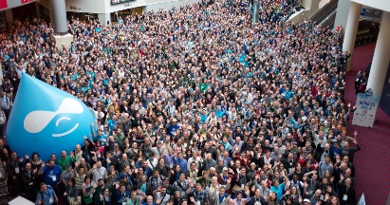
The Drupal community is a similarly large community with more than 1,000,000 passionate developers, designers, trainers, strategists, coordinators, editors, and sponsors that are working together to build Drupal, provide support, create documentation, share networking opportunities etc.
Image source: https://evolvingweb.ca/blog/drupal-associations-role-growing-community

1.4. Part 3 - How members of FOSS communities communicate and collaborate at local, national and transnational level

Live communication
The IRC Live Chat is commonly used for user support and general discussion within community members, like for example the members of the FSF join each other each Friday in the IRC Live Chat channel irc://chat.freenode.net/fsf for their scheduled meetings or the OSI uses the #osi channel for their live chats. In the community pages (f.e. in the ‘Free Software Directory blog’) users find information, like the meeting topics or older minutes.
Image Source: https://www.pexels.com/photo/business-composition-connection-desk-209663/

Mailing lists
Mailing lists are another usual way to communicate with subscribed community members. At the OSI for instance, there are many global and regional mailing lists, for announcements, discussion, licensing or other topics. Users can easily follow the discussions, while the path to a successful and fulfilling collaboration is being smoothed.
Image source: https://www.pexels.com/photo/brown-paper-envelope-on-table-211290/

Live events, Meetups, Summits and Conferences
Community members are also meeting each other at community events, where they can meet face to face, swap tips, and get inspiration for their ongoing and next projects, making friends along the way. WordPress, for example, has ‘WordCamps’ all over the world, even more Meetup groups, and conferences like ‘Pagely’s annual PressNomics’.
Image source: https://www.pexels.com/photo/people-sitting-watching-in-the-theater-301987/

Working groups
Other projects, like Drupal, have ‘Community Working Groups’ that uphold the community’s Code of Conduct and maintain a friendly and welcoming community for members and newcomers.

Forums
Forums and Wikis offer communities a huge knowledge bank that supports both developers and users and are considered as another effective way to contribute and help others.

Assessment

Are you ready to say how communities work with each other?

(Yes or No)

Communities are diverse and highly motivated groups of developers and end-users
Yes
No

Communities are not supported by initiatives, foundations or associations, but only from their own users.
Yes
No

Check all that apply

The ways to collaborate with members of a FOSS community are:
through Online-Chats
subscription in Mailing-lists
organisation of teleconferences with community leaders
participation in Live events
visits to company offices

The main international FOSS communities are the:
WordPress- community
Moodle- community
Microsoft community
Github- community
Apple-community

(Fill in the blank)

If an SME is new to FOSS, it should be considered to hire someone who has already collaborated with a FOSS community, so they can provide guidance to the SME concerning how to both contribute and gain the most from such communities. Experienced contributors can act as mentors and help SME employees pursue the FOSS pathway.

Summary

Communities are diverse and highly motivated groups of developers and end-users, supported by initiatives and foundations or associations. There are a lot of ways to contact members of the community and get involved by contributing to the development of new tools and exciting solutions. The main international FOSS communities are The WordPress-, the Moodle-, the Github- and the Drupal-community. Their members communicate and collaborate with each other using live chats, mailing-lists, by organising live events or by working together in online-groups and forums.

